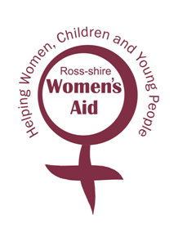
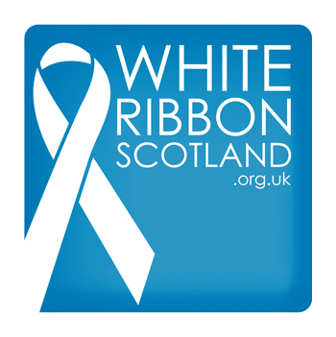

Participants Name : ________________________________________________
Address : ________________________________________________
________________________________________________

Will you provide own shoes? YES NO
If no, what is your size?
I hereby pledge that I will support Ross-shire Women’s Aid and White Ribbon Campaign and participate in THESE HEELS ARE MADE FOR WALKING: A charity walk in High Heels. I will try and raise as much sponsorship as I can and speak out against Male Violence Towards Women.

Participants Signature : ______________________________________________
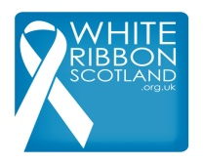
Registered Charity : 1123874 Registered Charity : SC008514

